April 21, 2019

Instructions
Passing this exam is the final step in the Olympia Mountaineers Navigation course. You’ve come a long way and the end is within reach. Use the materials and knowledge that you’ve accumulated over the last week to answer these questions. Thank you for taking the course.
Return the exam, emailed or postmarked by May 5, 2019, to Mike Kretzler, mkretzler@comcast.net or 1615 Easthill Ct NW, Olympia, WA 98502.
Note: All bearings are in true north and all UTM coordinates use NAD27. The UTM is provided as a reference to location, to help you find the points, not as part of the exercise.
- Match the features below with each of the map snippets. (Put the correct letter in the boxes.)
 | gentle slope |  | cliffs |  | ridgeline |  | peak

A | B | C | D
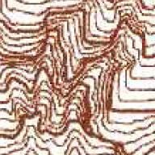 | 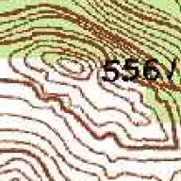 | 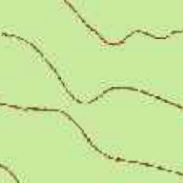 | 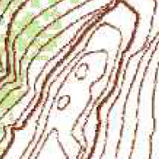
- Which of the following is true about magnetic declination? (Mark the correct answer.)
Declination changes over time and location.
Some places have zero declination.
Computing declination in the field is difficult.
All of the above.
- What’s the best angle between two lines (bearings, features, contours, etc.) to use for triangulation for determining your position? (Mark the correct answer.)
 | 15° |  | 60° |  | 90° |  | 120°
- You’re following a course of 65° with a partner. You are ahead and have turned to face your partner. What back bearing would you use to check your partner’s bearing? (Mark the correct answer.)
 | 0° |  | 65° |  | 180° |  | 245°
- Which of these is a coordinate system? (Mark the correct answer.)
 | Mercator |  | UTM |  | Declination |  | Map datum
- Which of the following are among the duties of the navigator in a group? (Mark the correct answer.)
Tracking current location
Communicating with the group
Identifying escape routes
All of the above
Use these two points for the next two questions: Point A: 10T 600000mE 5190540mN
Point B: 10T 603100mE 5190540mN
- What’s the distance, in meters, between Point A and Point B? ___________________________
- What’s the direction from Point A to Point B (either N, E, W, S or degrees)? _________________
Use your copy of the USGS Mt Rainier East to answer the following questions:
- What’s the map scale? ____________________
- What are the contour intervals? ____________________
What declination adjustment is marked on the map? ____________________
What’s the highest elevation on the map? ____________________
- What’s the elevation of top of Plummer Peak (SW corner of map)? ____________________
What’s the elevation of Panhandle Gap (NE corner of map)? ____________________
What’s the difference in elevation, in feet, between Fan Lake (10T 601180mE 5183260mN) and where its outlet joins the Muddy Fork of the Cowlitz River (10T 602930mE 5182620mN)?
____________________
What’s the bearing from Alta Vista BM5940 (10T 596520mE 5182610mN) to Cowlitz Rocks (10T 598940mE 5185180mN)?
____________________
What’s the straight-line distance, in miles, between the footbridge over Box Canyon (10T 604180mE 5179960mN) and where the Wonderland Trail reaches the road at Reflection Lakes (10T 597500mE 5180080mN)?
____________________
What’s the distance, in miles, along the Wonderland Trail from the footbridge over Box Canyon to Sylvia Falls (10T 601180mE 5179680mN)?
____________________
You’re on a scramble and you want to use triangulation to pin-point your location. You are sure of your identifications (and assume you can see the points identified), so you take these two bearings:
293° to Alta Vista BM5940 (north of Paradise Park) (10T 596520mE 5182610mN)
208° to Peak 6524 (Foss Peak in the Tatoosh Range) (10T 598400mE 5178560mN)
On what major, named feature are you standing? ______________________________________
What’s the nearest labeled point to your location? _____________________________________
What is your approximate elevation, in feet? ____________________
You are planning to use the trail from the road by Reflection Lakes to the saddle between Plummer and Pinnacle Peaks. Answer the following questions:
- What is the overall elevation gain, in feet, to the saddle? ____________________
- What is the approximate distance, in miles, to the saddle? ____________________
- Estimate the time, in hours, for the one-way hike to the saddle (assume 2 miles per hour plus 30 minutes for each 1000’ of elevation gain):
____________________
- Which part of the hike – the first half or the second half – is steeper? ____________________

